Nursery Activities week 15 6th July
. Here are some activities for home.
Theme –Space
Draw an Alien
Aliens are great to create as they can look however you want. Make an Alien using pens, paints, glitter or glue – no limits. Get messy and have fun!
Make a rocket
Now make your Alien a Rocket or spaceship, if you are anything like us at the moment then there is lots of recycling boxes and even amazon boxes about at home. Space ships can be big or small depending what you have got at home! If its big go on an adventure to space and even have a picnic in it – the fun is endless with a box rocket!!!
Star Gazing!
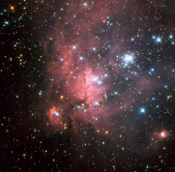
If you child happens to be up when it is dark (hard this time of year so please do not keep them up especially) have a look at the stars, can they see patterns? Which one do they think the Aliens live on? If you know what some of the constellations are then discuss. The internet is a great place to find out their names, there are various aps to help know what you are looking at.
Space themed stories
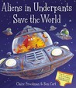
Listen to a space themed online story:
Aliens Love Underpants​, https://safeyoutube.net/w/ZYg6
​Roaring Rockets​ https://safeyoutube.net/w/mZg6
​Whatever Next?​ https://safeyoutube.net/w/tZg6
Which is your favourite? Why?

