Nursery Activities week 13 22nd June
It has been yet another fantastic week in the ‘Bubble’ the Nursery pupils have been amazing, finding the baby birds nest was a particular highlight. This week on Monday and Tuesday we are going to learn more about birds and complete bird related activities.
Here are some activities for home.
Theme –Birds
Birds Nest
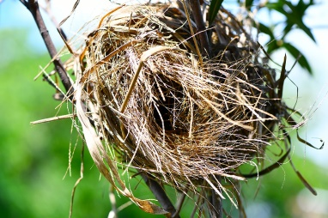
Make a birds nest, using strips of paper, straw or whatever you can find have a go at making a birds nest and even make eggs (playdoh?) and talk about the fact the eggs will hatch into baby birds.
Ducks (appropiate after all the rain we have had!!)
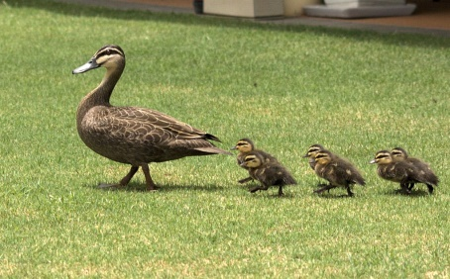
Have duck themed day if you can go local pond go and feed the ducks, practise quacking like duck, waddle like a duck and even splash like a duck in the bath!!

Attached is a page of ducks to hide around house find and count. Order them from biggest to smallest. Put out 5 ducks and add one more or take one awaynd recount.

