Learning Project - Under the Sea
Week 8 18th-22nd May
Age Range: ​Reception Each task 20-30 minutes then have a break
Please find all phonics activities for this week detailed on this sheet under Weekly Phonics section
Weekly Maths Tasks | Weekly Reading and Writing Tasks
Please see seesaw  Tasks will be posted daily Monday-Friday, please post photos, short videos and Audio files for us to approve and comment on. | Please see seesaw  Tasks will be posted daily Monday-Friday, please post photos, short videos and Audio files for us to approve and comment on.
Weekly Phonics Tasks (aim to do one per day) | Weekly Spelling tasks
Monday- ​Ask your child if they can hear the sounds that come at the beginning of snail​ and whale​​. Can they think of/ or find other things that begin with the same sound? They could create a poster or take photographs of the things they see. | This weeks spellings are the tricky words:  have, like, some, come, were, thee, little, one
Tuesday- ​Buried Treasure: Write out some real words and made up words (e.g. tud, jup, fub). Place these in a pile and using 2 containers, label one as ‘Treasure’ and the other as ‘Bin’. Can your child read the word and decide if it is real? If it is real it goes in the treasure chest, if not it goes in the bin. Simplify this activity for Nursery by sounding the words out for them.
Wednesday- ​Play ​Buried Treasure​ online on Phonics Play.
Thursday- ​Sing ‘1,2,3,4,5 Once I caught a fish alive’. Click ​here​ for the words. Can your child learn this by heart?
Friday- ​Play Fish for Sounds – write out some letter sounds that correspond to objects found in the sea – sh for shell, f for fish. Try and write them outside in chalk or similar and encourage your child to trace over them.
Learning Project - to be done throughout the week
The project this week aims to provide opportunities for your child to learn more about life in and around the sea. Learning may focus on the strange and wonderful creatures and plants that occupy our oceans, their habitats and how human beings affect this environment.
After listening to the story, ‘The Snail and the Whale’ ​(see reading task).
- Take your child on a snail hunt around the garden. Can they think about the places a snail might want to live?
- Show your child a ​picture of a sea snail.​ Ask, how is it different from the snails they found in the garden?
- Have a ​Snail Race-​ Use chalk to draw out lines on the ground (or sticks to mark out the lines) to create a race track. Place your snails at the starting line and watch them go! You could give your child a timer to measure how long it takes for the snails to make their way across.
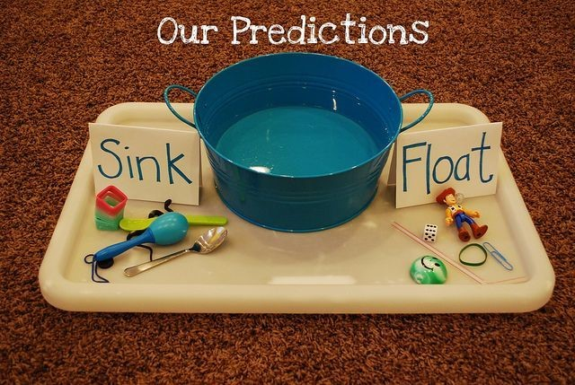
Make your own Fishing Game
- Make a fishing rod using a stick or similar (a wooden spoon would work well!). Tie some string on to one end and tie a magnet onto the end of the string (you could use a fridge magnet).
- Using the rod, your child could explore which items are attracted to the magnet around the house
Explore Floating and Sinking
- Fill up a bowl, sink or basin and provide your child with a range of objects to explore. Which ones float and which sink? Ask them why they think they float/ sink? ​CHALLENGE: Keep a record of the objects that float and sink? This could be using pictures or written.​

