Nursery Activities week 8
Theme: Under the Sea
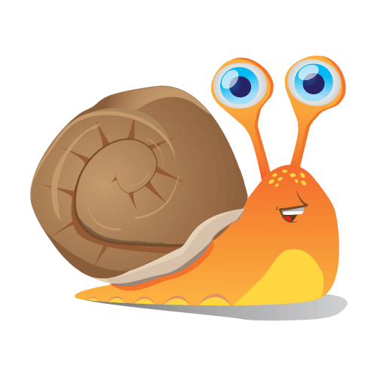Snail Writing
Have a go at snail writing. Using hair gel, shaving foam, washing up liquid, shampoo etc show you child how to produce the letter s for snail and the letters of their name. you may want to do this outside or even in the bath. get them to use their pointy finger of their dominant hand (if they have one yet) to trace the letters over and over again.
Repeating Patterns
A repeating pattern can be anything, have a little fun this week creating a pattern using handclaps, eg clap hands, tap kneww, clap hands, tap knees etc.
You could even make a pattern yourself and get them to copy even introduce pots and pans! Have noisy fun!!!
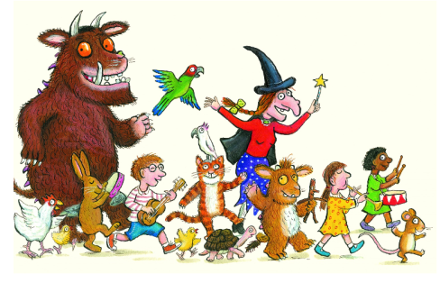Read, read, read it is so important that children hear story language. Read favourite stories that the children can join in with. The rhythm and repetition is very important for early reading. Julia Donaldson books are fantastic for this. BBC I-Player have some lovely stories available at the moment. Here are some fishy themed stories is you don’t have any at home:
The snail and the Whale by Julia Donaldson https://safeyoutube.net/w/ivS5
Sharing a shell Julia Donaldson https://safeyoutube.net/w/0vS5
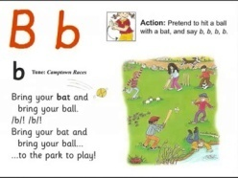Youtube: Jolly Phonics Phase 2 https://www.youtube.com/watch?v=U2HYM9VXz9k – The children should be learning to sing the songs and join in with the actions.
Yoga
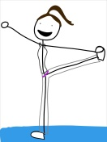Try Cosmic kids Yoga –https://www.youtube.com/watch?v=qC83oFEeVZA This is an under the sea themed clip. if you go onto you tube and type ‘cosmic kids Yoga under the sea’ there are quite a few clips the pupils will enjoy.

