Nursery Activities week 11
Theme – Outdoors and Mini beasts
It has been lovely getting to meet the Nursery pupils, in school on Monday and Tuesday we will be talking about animals that live in the rainforest with the older children and animals that live in and around school with the younger pupils. We plan to go out weeding and tidying our forest school area and hunting for little beasties.
Here are some activities for home.
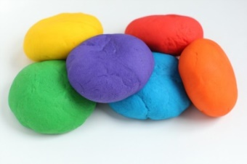
https://www.bbcgoodfood.com/howto/guide/playdough-recipe Here is a good playdough recipe. Talk to you child about what mini beasties live in our gardens and then make together – worms, snails, ladybirds and beatles or even a millipede with lots of legs. (As well as fun playdoh play helps strengthen hand muscles used for writing – you have all had a dough disco resource on seesaw recently)
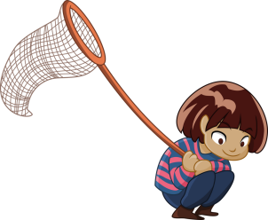 Summer is coming! First the sun and now the rain. Small people cannot get enough of looking for creepy crawlies. What can you find? Can you count how many of each species you find? Do they all live in the same places or have different homes or habitats. Remember to return the bugs to their homes at the end.
Mark making is an essential skill which children need to do lots before they start to write. Giving meaning to the marks they make is the first step in learning to write so let’s encourage them to do it! They can use chalk, paint, crayons, pencils, water and a paintbrush outside. Encourage them to explain what they have created.
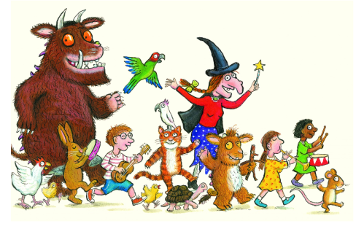Read, read, read it is so important that children hear story language. Read favourite stories that the children can join in with. The rhythm and repetition is very important for early reading. Julia Donaldson books are fantastic for this. BBC I-Player have some lovely stories available at the moment.

Youtube: Try Cosmic kids Yoga – The Very Hungry Caterpillar https://www.youtube.com/watch?v=xhWDiQRrC1Y or a mini beast themed one at https://www.youtube.com/watch?v=qIT-9Nnlvn0

