Learning Project WEEK 7 – Celebrations
11th-15th May
Age Range: Reception
Each task 20-20 minutes then have a break
Weekly Maths Tasks | Weekly Reading and writing tasks Tasks (
Please see seesaw  Tasks will be posted daily Monday-Friday, please post photos, short videos and Audio files for us to approve and comment on. | Please see seesaw  Tasks will be posted daily Monday-Friday, please post photos, short videos and Audio files for us to approve and comment on.
Weekly Phonics Tasks (Aim to do 1 per day) | Weekly spellings
- Sing Nursery Rhymes and songs together. Add in actions and change the words. Can children think of different rhyming words to add in? Repeat old favourites and learn new rhymes. You can find an A-Z of Nursery Rhymes.  - Also see activities on phonics sheet attached. | This weeks spellings are:  The tricky and high frequency words:  he she we me be was you they all my her said so
Learning Project - to be done throughout the week
This project this week aims to provide opportunities for your child to learn more about celebrations. Learning may focus and different types of celebrations that take place and who may celebrate them. It could look at how people celebrate different events differently in other parts of the world.
- Family Photographs-
Look over a selection of photographs of family celebrations and discuss with your child: what the celebration was about, who attended, what you did to celebrate, when it took place, whether it is an event that happens each year. Can your child remember the event taking place? What do they remember of it?
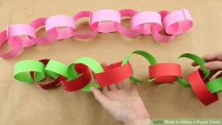
- Plan a family celebration-
Decide on a family celebration for the week. This could be a family indoor picnic, meal, dance etc. Ask your child to write invitations to family members to the party.
Create homemade decorations using coloured paper (If you do not have coloured paper at home, you could use old newspaper or wrapping paper) You could make paper chains or bunting
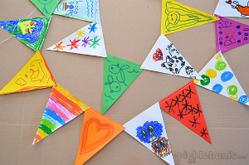
Plan a menu for the party and make the food together.
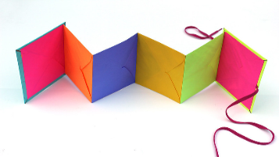
Birthdays-
Talk to your child about when they were born. Look at photographs of the day they were born, if you have them available. Do they know the date of their birthday? Support your child to create an all about me folding book (as pictured) with their birth date, current age and anything else they think is important for people to know about them.

