Nursery Activities week 7
I don’t like it!!!
Try something new. We all like certain things and often children can have a very limited diet. I am the Mum of a very fussy eater!! This week I would like to challenge children (and parents) to try something they have not had before or previously didn’t like. I don’t like Blueberries very much, so this week I will try them again and see what I think.
Repeating Patterns
Make a repeating pattern at home using resouces around your home this could be cutlery, toys, shoes, eg fork, spoon, fork, spoon or red shoe, red shoe, slipper, red shoe, red shoe, slipper. Can a grown up start the pattern and your child carry it on.
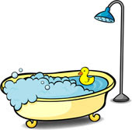Floating and sinking
Supervised water play can be so much fun, please can our child investigate what objects float or sink This can done in a paddling pool, bath or even using a washing bowl. They can even sort the objects by what floats and what sinks.

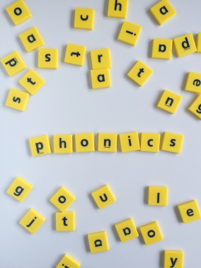 Early phonics
Have a look for different items around the house that start with the first letter of their name and then s,a,t,p. What is their favourite thing that they find?

