Nursery Activities week 4
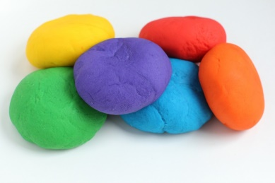
https://www.bbcgoodfood.com/howto/guide/playdough-recipe Here is a good playdough recipe. If you can make it it is a great resource to use with your children. They can cut, roll, squash and squeeze, all of this is developing their fine motor skills ready for when they start to write. Encourage them to tell you what they have made in order to develop their imaginative skills and language and communication skills.
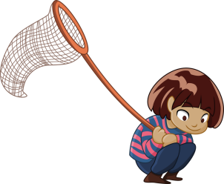 Spring is still here. The weather is beautiful and it is a great time to spend as much time in the garden. Bug hunting is a great activity. Can you find any interesting creepy crawlies in the garden? Collect them gently (a jar or bowl with cling film over the top with a couple of air holes in works a treat) Do the children know what they are called? Can you look up any you are not sure on? Do all ladybirds look the same? Remember to return the bugs to their homes at the end.
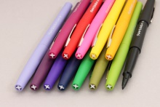Mark making is an essential skill which children need to do lots before they start to write. Giving meaning to the marks they make is the first step in learning to write so let’s encourage them to do it! They can use chalk, paint, crayons, pencils, water and a paintbrush outside. Encourage them to explain what they have created.
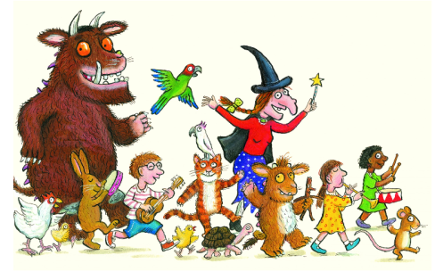Read, read, read it is so important that children hear story language. Read favourite stories that the children can join in with. The rhythm and repetition is very important for early reading. Julia Donaldson books are fantastic for this. BBC I-Player have some lovely stories available at the moment.
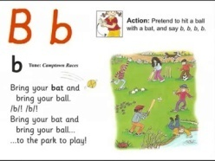Youtube: Jolly Phonics Phase 2 https://www.youtube.com/watch?v=U2HYM9VXz9k – The children should be able to sing the songs and join in with the actions.

Youtube: Try Cosmic kids Yoga – The Very Hungry Caterpillar https://www.youtube.com/watch?v=xhWDiQRrC1Y

