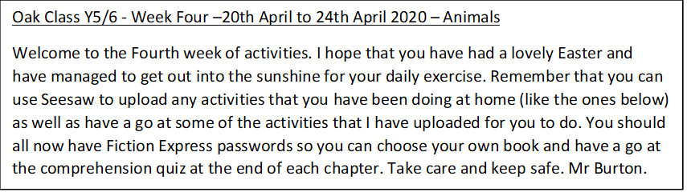

Learning Project WEEK 4 - Animals Age Range: Y5/6
Weekly Maths Tasks (Aim to do 1 per day) | Weekly Reading Tasks (Aim to do 1 per day)
- Get your child to play on Times Table Rockstars.  - Ask your child to show everything they know about decimal numbers and/or percentages on a piece of paper. This could be pictures, diagrams, explanations, methods etc. Get them to be as creative as they want to be.  - Direct your child to play on Hit the Button - focus on times tables, division facts and squared numbers.  - Encourage your children to compare decimal numbers on this game.  - Arithmetic practise on Maths Frame.  - Get your child to work on their reasoning and problem solving by practising past SATs questions that are broken down into topic areas and have videos linked to them that can be watched if needed. As these are older papers these are suitable for both years 5 and 6. Click on one of the topic areas listed to gain access to the questions. | - Get your child to read a book on Fiction Express and complete the comprehension quiz at the end of each chapter.  - Remind your child to continue to read a chapter from their home reading book or a book that they have borrowed from the library.  - When they have completed the chapter, ask them to re-write this from the viewpoint of another character.  - Encourage your child to note down any unfamiliar words from the chapter they have read. Explore the meanings of these words by using a dictionary, reading around the sentence or using print conventions.
Weekly Spelling Tasks (Aim to do 1 per day) | Weekly Writing Tasks (Aim to do 1 per day)
- Encourage your child to practise the Year 5/ 6 Common Exception Words (see list)  - Then ask your child to choose 5 Common Exception words. They can then write a synonym, antonym, the meaning and an example of how to use the word in a sentence.  - Practise spellings on Spelling Frame.  - Your child may wish to create a word bank about an animal of their choice which includes verbs, adverbs and expanded noun phrases. They can use this for their poetry writing.  - Get your child to proofread their writing from the day. They can use a dictionary to check the spelling of any words that they found challenging. This will also enable them to check that the meaning of the word is suitable for the sentence. | - Write a diary entry/newspaper report summarising the events from the day/week.  - Your child can write a formal letter to West Midlands Safari Park persuading them to close the park. They must justify their opinions with factual information.  - Choose an animal of their choice and think about how it moves, what sounds it makes and the environment that it lives in. Your child can then write a poem based around these ideas. They can repeat this activity for different animals.  - Your child now has an in-depth story plan. They can begin to write their story considering the devices needed for their genre. How will the dialogue convey their character and advance the action?  - Animal’s hearts should be cut up for science experiments. Do you agree/disagree? Ask your child to write a discussion about this statement.
Learning Project - to be done throughout the week
The project this week aims to provide opportunities for your child to learn more about key animals they are interested in. Learning may focus on exploring the physical aspects of an animal, their habitat, categorising animals etc.

- Animals and their Environment- Your child can describe how animals such as Emperor Penguins, chimpanzees and orcas have adapted to suit their environment. They can do this by writing a short summary after carrying out some research. After this, ask them to design a new wondrous animal that has evolved to suit its environment considering the environmental changes it has had to face over recent years.

- Where Animals Originate From - Ask your child to locate on a world map where different animals originate from and research why they live in these environments. Things for them to consider when researching why they originally lived in these countries are:
  - Food sources
  - Climate
  - Weather
  - Terrain
After doing this, ask them to think about how the animals they have selected have adapted so that they are able to live in the UK. Present your findings as a poster or in a PowerPoint presentation if they have access to a PC.

- Life Cycles - Ask your child to research a mammal, an insect, an amphibian, a reptile and a bird. They can then choose one and draw the life cycle of an animal and label the diagram accordingly. How does the life cycle of the chosen animal differ to a human life cycle?

- Animal Prints- Using a variety of media (this could be materials from around the house such as cloth, newspapers or magazines, felt, etc.), ask your child to create animal prints for a mammal, an insect, an amphibian, a reptile and a bird of their choice. After, they can create a collage of the animal prints they have made. They could always use a pencil or pen to sketch the animal prints!

- The Life of Darwin- Who was Charles Darwin? Ask your child to research the scientist’s theory on evolution. Where are the Galapagos Islands? What species did and do still live there? What makes these animals unique and extraordinary? Write a biography about the life of Charles Darwin.
Additional learning resources parents may wish to engage with
Classroom Secrets Learning Packs - These packs are split into different year groups and include activities linked to reading, writing, maths and practical ideas you can do around the home.
Twinkl - to access these resources click on the link and sign up using your own email address and creating your own password. Use the offer code UKTWINKLHELPS.
Headteacherchat - This is a blog that has links to various learning platforms. Lots of these are free to access.

